4. SYSTEM DESIGN

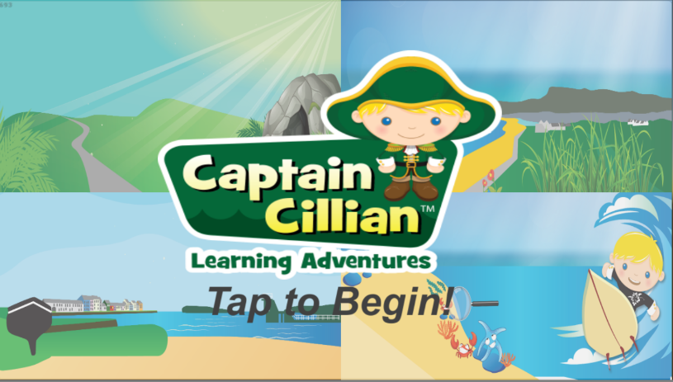- The first thing you see when you open the application. The Opening screen page.

- Boasts a bright, colourful theme that repeats throughout the game to make the design more appealing to the target audience.

- Displays the company logo and previews different scenes from the game.

- Tapping anywhere on the screen brings you to the Main Menu



-Designed well, shows all the different sections of the application.

-Attractive to the eye. Captures children’s attention.

4.1 Create and play

- 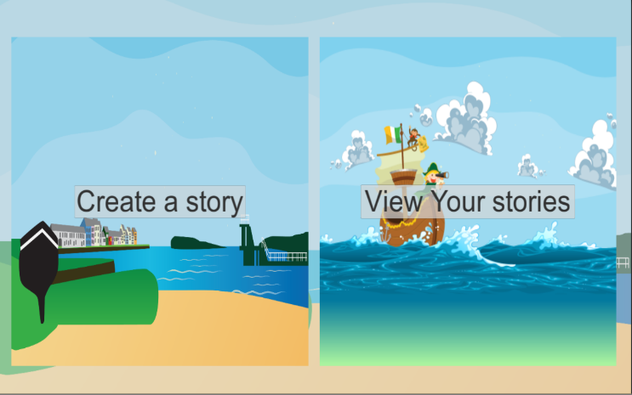This is the first thing you see when you choose the “Create and Play section”

- Choosing create a story will bring you to the scene in the next screenshot.

- You can view previously made stories from the “View your Stories” selection.

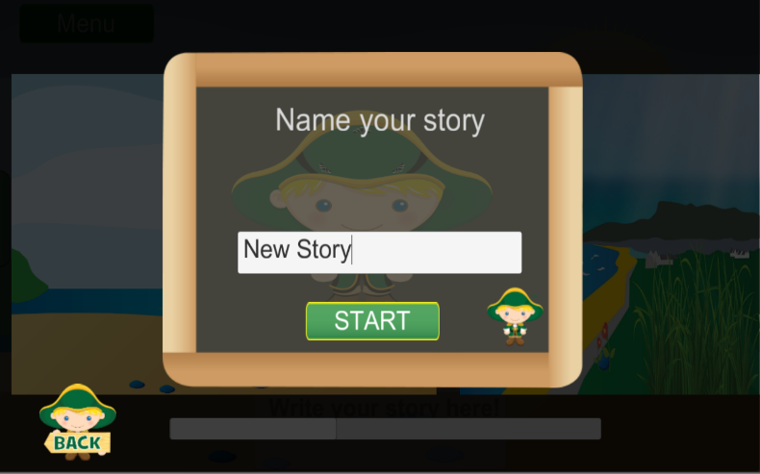-This is in the Create and play section.

- First, the user sets a name for their story

- While the user is naming the story, all required database calls are ran asynchronously to reduce waiting times.

-In this screenshot you can see a few images.

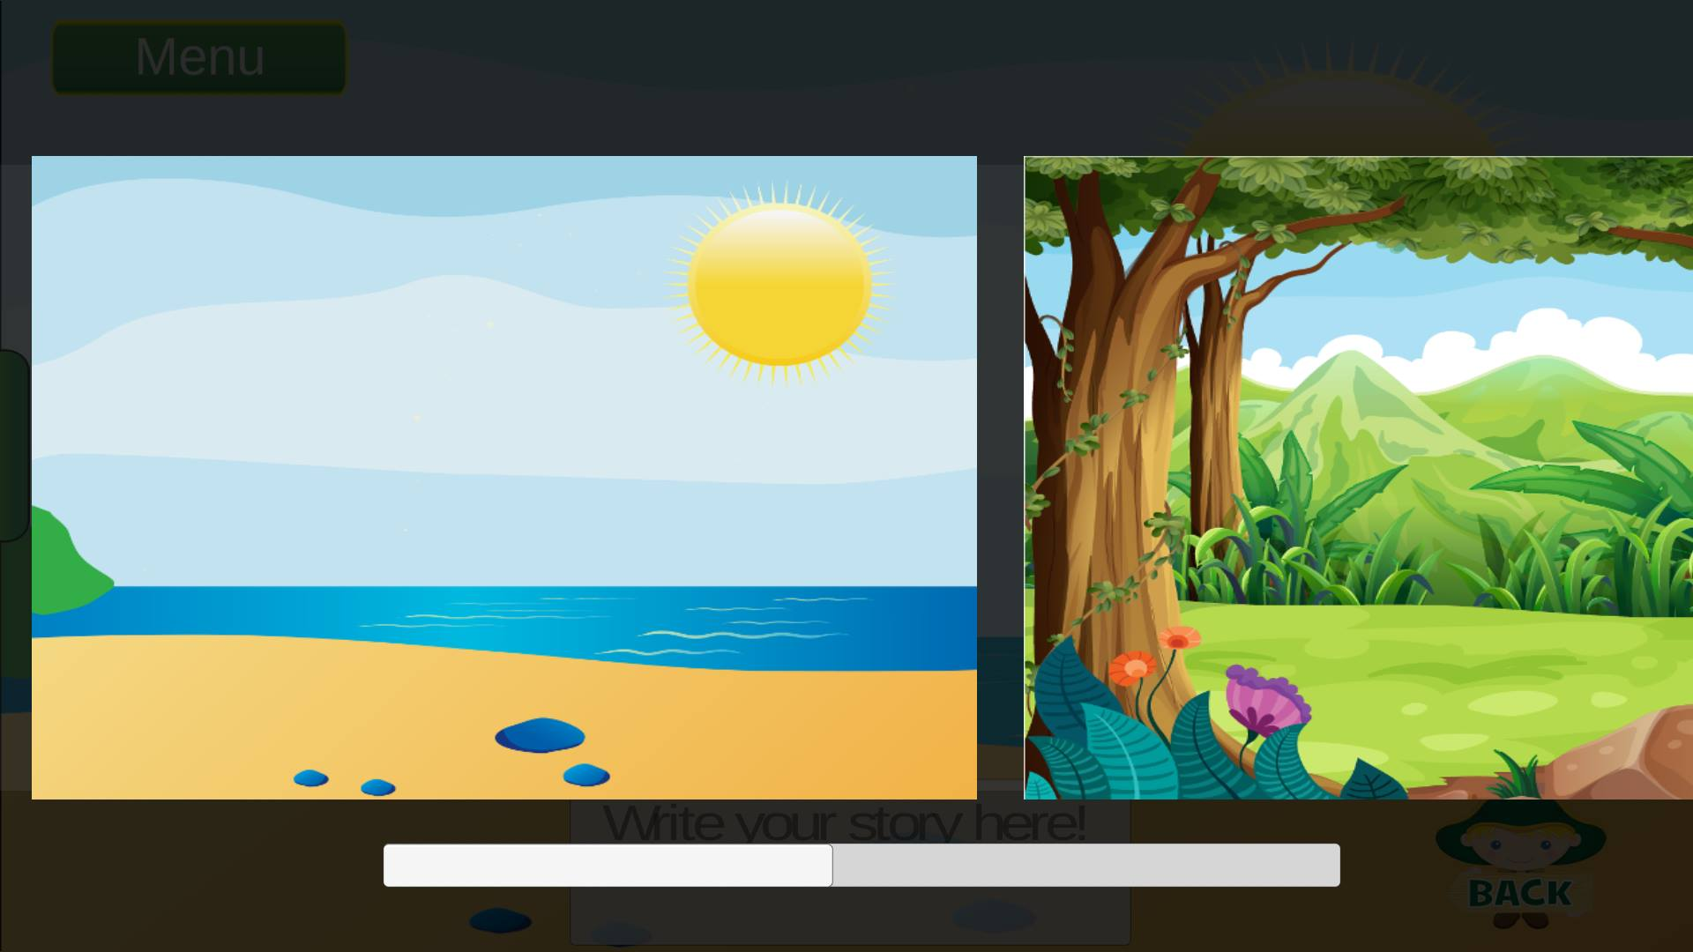

-These are the scenes you can choose to create your story.

-We are using many new features that we haven’t used before.

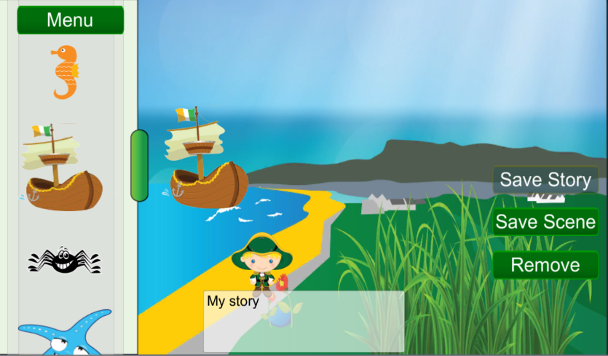

-This screenshot shows the game in action.

- A few of the icons have been added to the scene using the menu sidebar

- Every time a scene is saved, a snapshot is saved of the scene (ignoring UI elements to prevent clutter) and saved locally.

4.1.1 Story Viewer

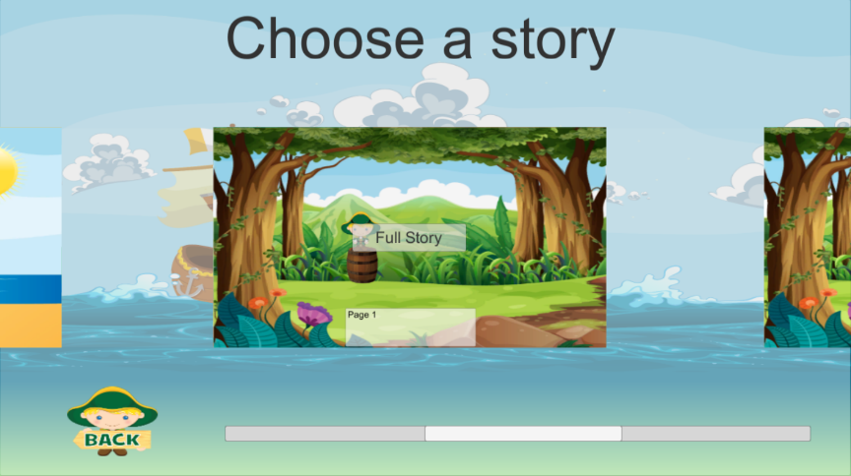

- The user is brought to this scene after finishing a story or by selecting “View your stories”

- Selecting a story allows the user to scroll through each scene in the story.

- 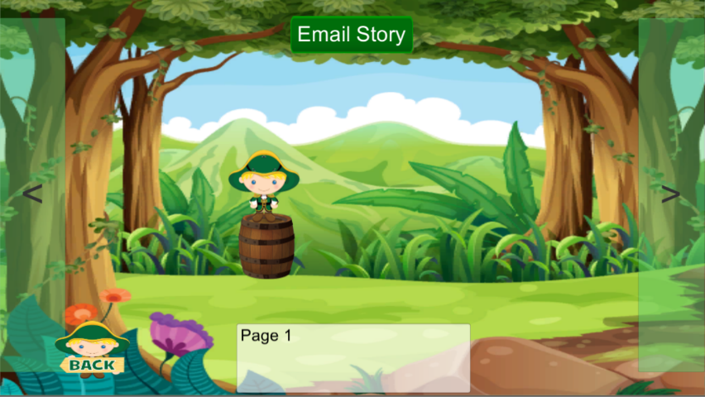This shows how the user can cycle through the different scenes on a selected story.

- The green arrow buttons allow navigation through each scene.

- The story can be emailed to a friend if the user has their email address saved in the main menu settings

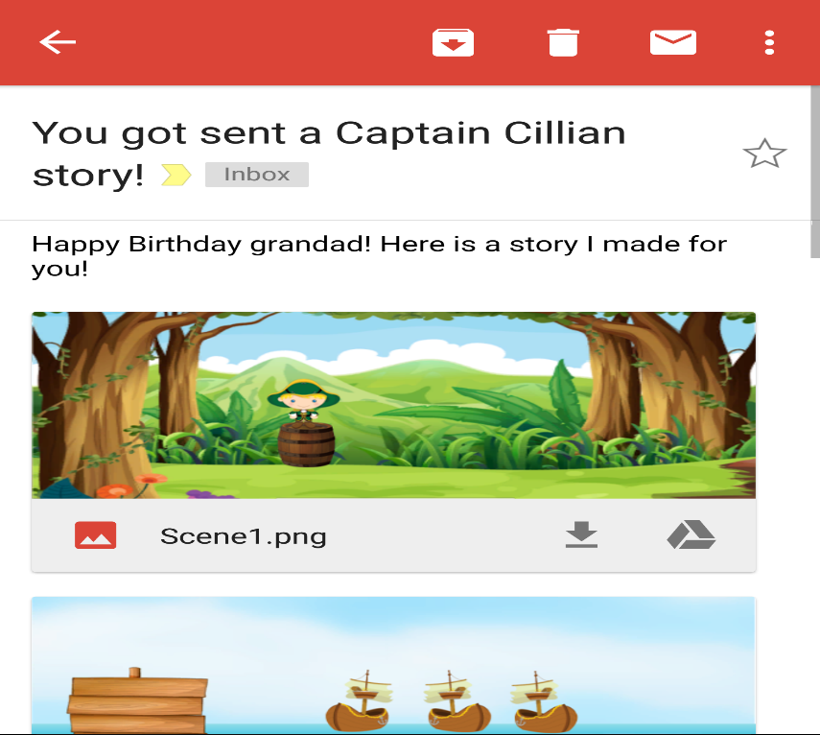

- This is an example of an email sent using the application. The user is able to write a short message and the story scenes are sent as email attachments.

4.2 Ocean Facts

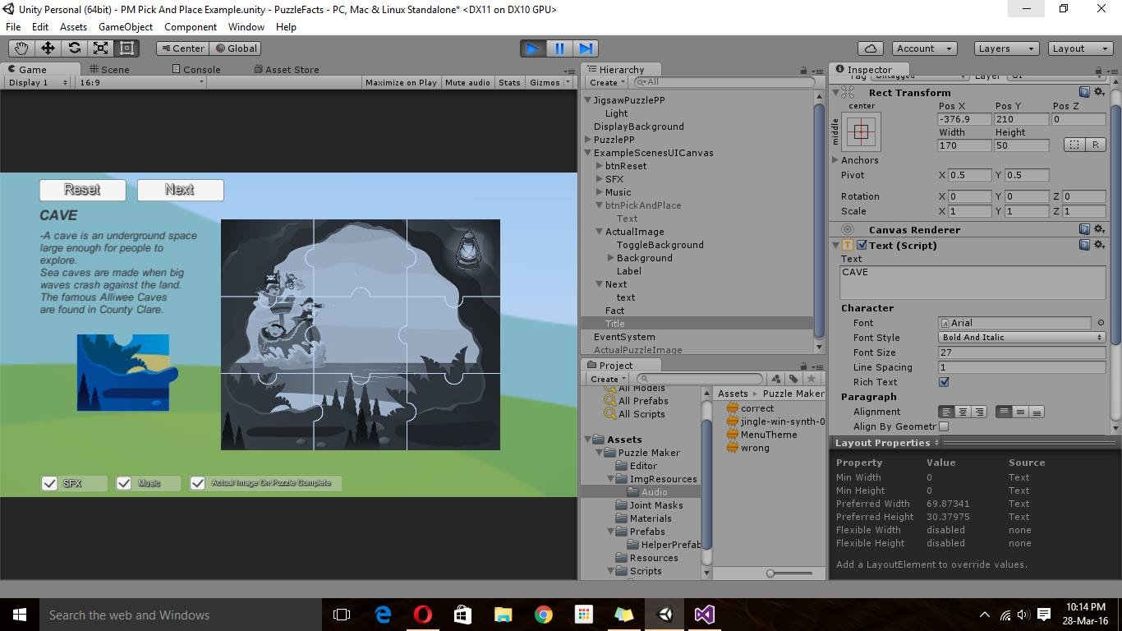

-This is the Pick and place puzzle game which displays one fact about one of the books.

- Smart approach in getting children to have fun and enjoy playing a game while also learning.

-This section implements sound .When the puzzle is completed.

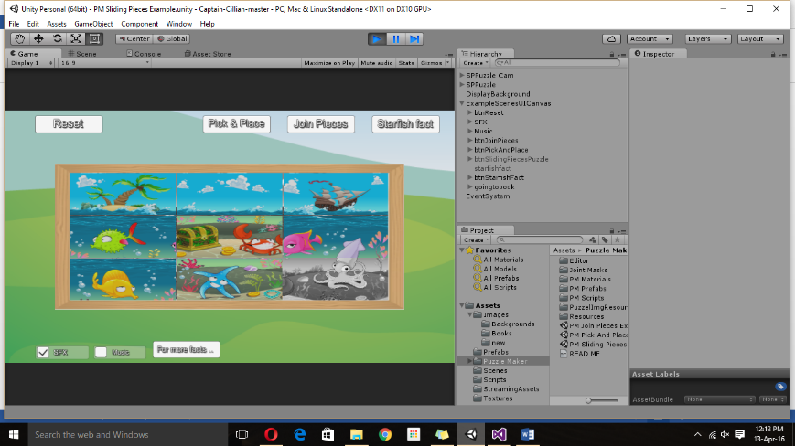-Added three different puzzles for each book.

-This is a sliding puzzle.

-At the bottom I decided to add a button that will bring you to one of the books.

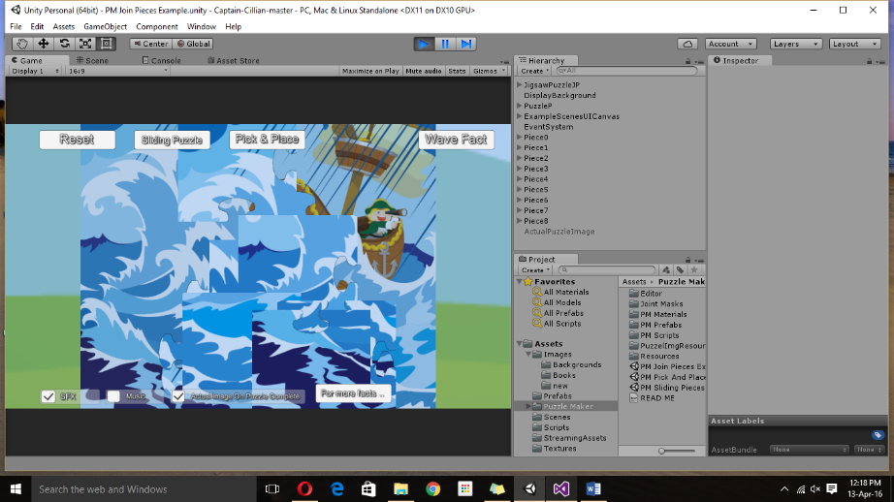-This is a Join the pieces puzzle.

-That also contains one fact about another book.

-Decided to add only one fact per book since the customer is using this as a promotion software.

- So in the button “For more fact…” customers will be brought to the website where they can buy the book to find out more facts.

4.3 Learn Irish

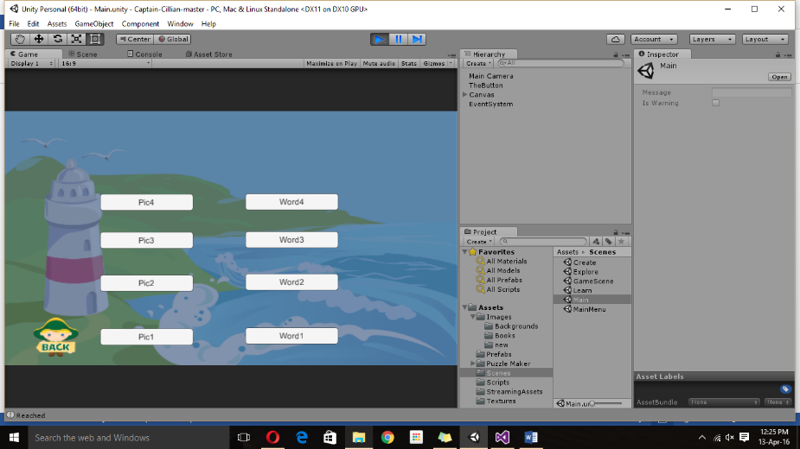

-In this section we added a match the word and picture game.

-After researching this we found that it would be the most effective way for children to visualize and also learn Irish words.

-It will be useful for using in the classrooms as our client is visualizing this to be used in schools.

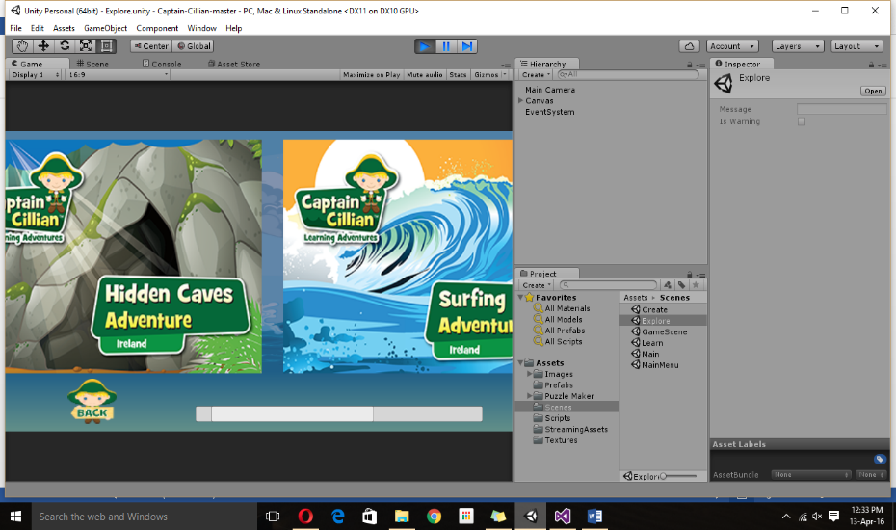4.4 Explore

-The explore section will only contain the selection of books that have been made.

-Each book will be linked to a website there the book can be bought.

-This is the best way we can promote the clients books and also the clients website

4.5 Database

The following screenshots show our database and how the database functions. We chose to use this particular database because it has a free trail for one year. Our client wasn’t sure she wanted to use a database to upload more information on this application. She initially wanted to create a new app for each batch of books she created. But since we had to add a level of complexity to our project we decided to give her this option. After the year passes she has the choice of continuing to use this or to leave it aside.

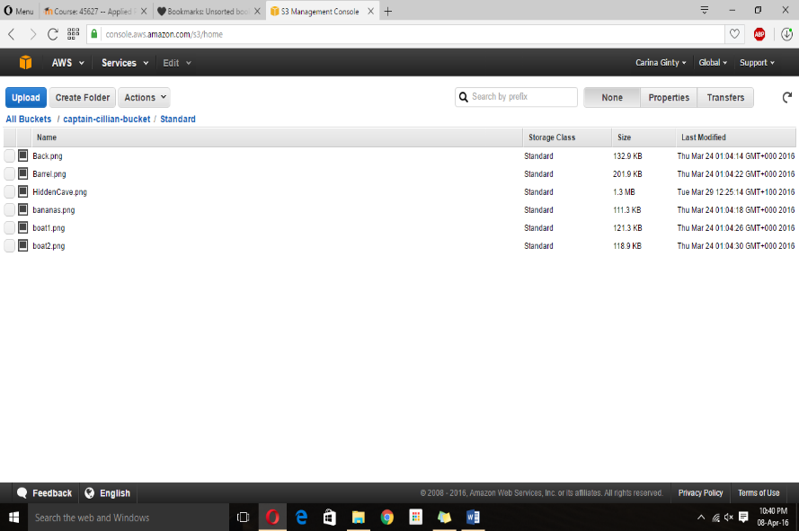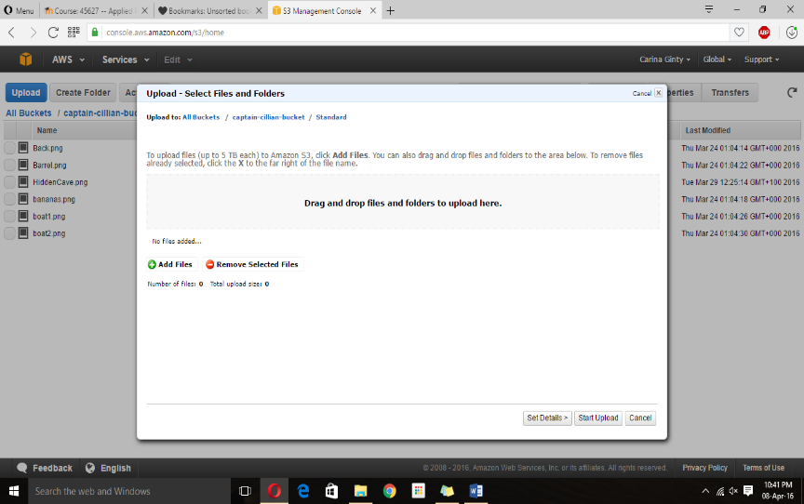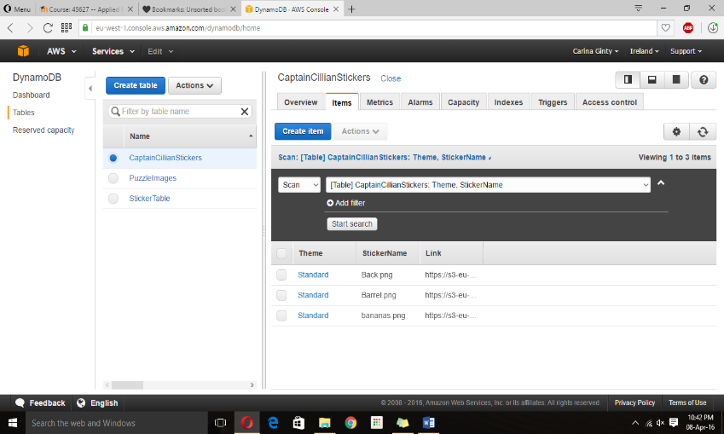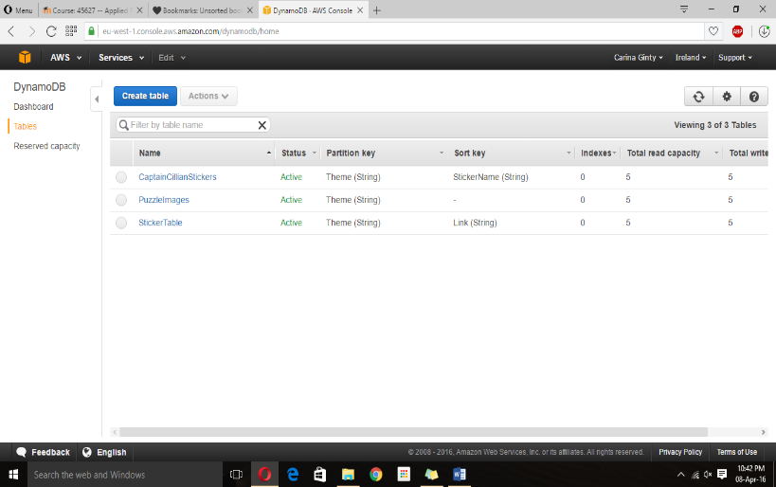Initially, the images themselves were saved as a Base64 string to the database, as DynamoDB uses Key/Value pairs to store data. However, downloading and converting each string proved to be too slow to allow for scalability, so the system was redesigned to use Amazon S3 (Simple Storage Service). The database was changed to store the image links and any additional information required. When the program is ran, it runs a scan on the relevant database table, and for each object in the table it finds, it saves and uses the link to search S3 for the equivalent file.   
For example, an image called “Test.png” will be saved like so in DynamoDB:   
*Theme: “Standard”  
StickerName: “Test.png”* When the respective section makes a call to the database, it will find “Test.png” and subsequently search for it under the folder “Standard” in S3.

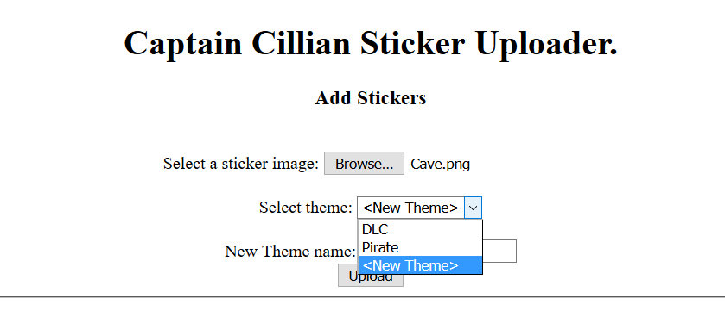

In order to add to the database without logging in manually, a static page was made in NodeJS to allow uploading of additional images. The page makes a call to the database and returns a Set of each Theme in the database. These are then used to populate the “Select Theme” drop-down list. The administrator can also create a new theme. The Upload button will then save the selected image using the given parameters to both S3 and DynamoDB.